Press release

Shanghai November 14, 2019

Switzerland Showcases Excellence in Fintech with 10 Top Fintech Startups’ Roadshow in Hong Kong and Shenzhen

Shanghai, November 14, 2019 – Venture Leaders Fintech 2019, a 6-day pitching and fundraising roadshow co-organized by Venturelab and swissnex China took place from November 3rd to 9th in Hong Kong and Shenzhen. The 10 leading Swiss Fintech startup were selected by an expert jury among nearly 60 applications. The startups participated at the Hong Kong Fintech Week as well as in mentoring workshops, investor meetings, pitching events and visits across Hong Kong and Shenzhen financial ecosystems.

For the first edition of Venture Leaders Fintech in Hong Kong, swissnex China and Venturelab led the Swiss startups on a six-day roadshow in China’s Greater Bay Area, one of the world’s most dynamic regions. This intense program provides the startups with 12 pitching occasions including two flagship events: a Pitch Cruise event aboard the iconic red-sail boat Aqua Luna, and a Sky Pitching event on the 100th floor of the International Commerce Centre. The startups gained unparalleled exposure to the local Fintech and financial ecosystem, along with mentoring opportunities, connecting with investors and getting exclusive insights from industry experts and interested parties, including CIGP, Eureka Nova, GP Bullhound, Howse Williams, HSBC, InvestHK, LGT Bank, SC Ventures by Standard Chartered, Oriente, UBS and WeLab.

Venture Leader Fintech Pitch Cruise

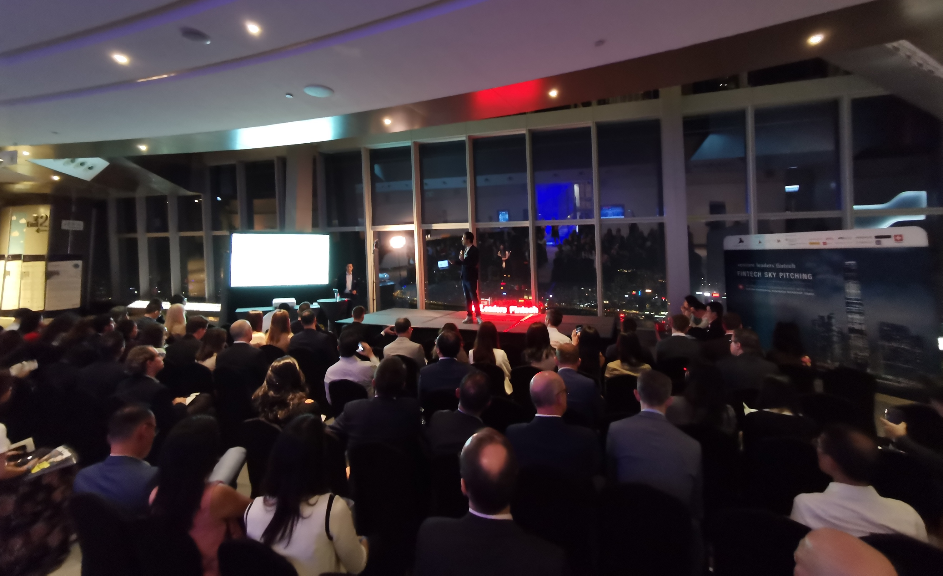
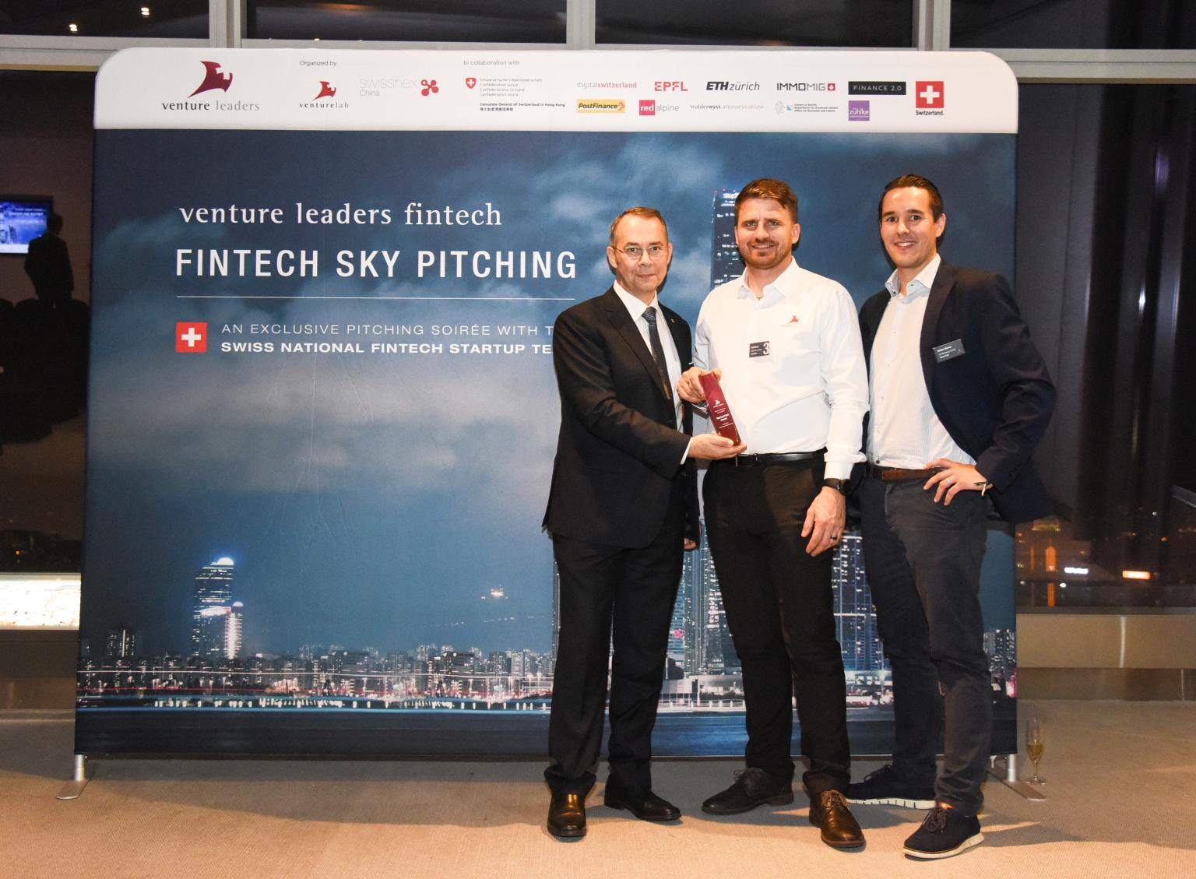

Venture Leader Fintech Sky Pitching

Additionally, swissnex China and Venturelab together with the Consulate General of Switzerland in Hong Kong represented Fintech in Switzerland with the “Swiss Fintech Pavilion” during Hong Kong Fintech Week 2019, world’s first cross-border Fintech event. The Swiss Fintech Pavilion was inaugurated by Mr. Paul Chan Mo-po, Hong Kong’s Finance Minister as well as Mr. Rolf Frei, the incoming Swiss Consul-General in Hong Kong, and Suzanne Streit, Embassy of Switzerland in China. During the Fintech Week, Suzanne Streit and Dr. Felix Moesner, Science Consul & CEO of swissnex China joined a panel with Prof. Marlene Amstad, Vice Chair of the Board of Director, Swiss Financial Market Supervisory Authority FINMA on “The Swiss Regulatory Approach on Fintech”.

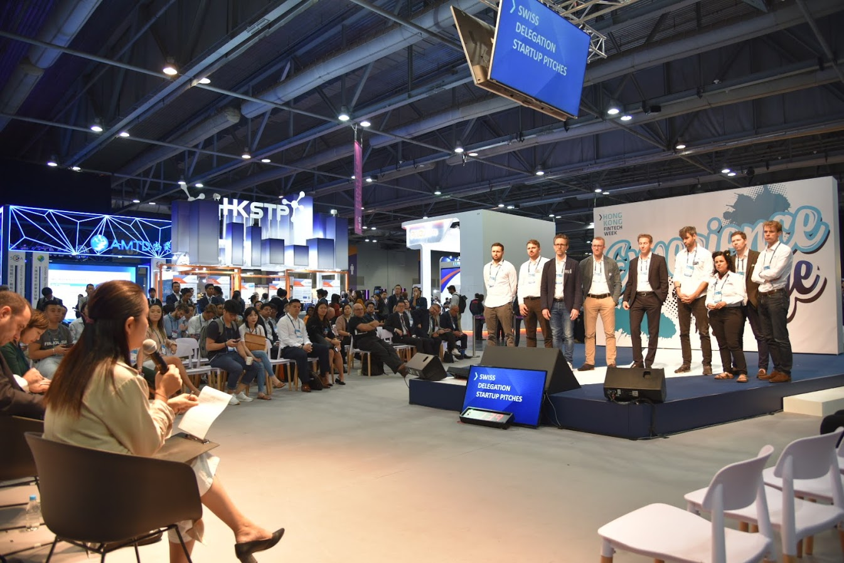
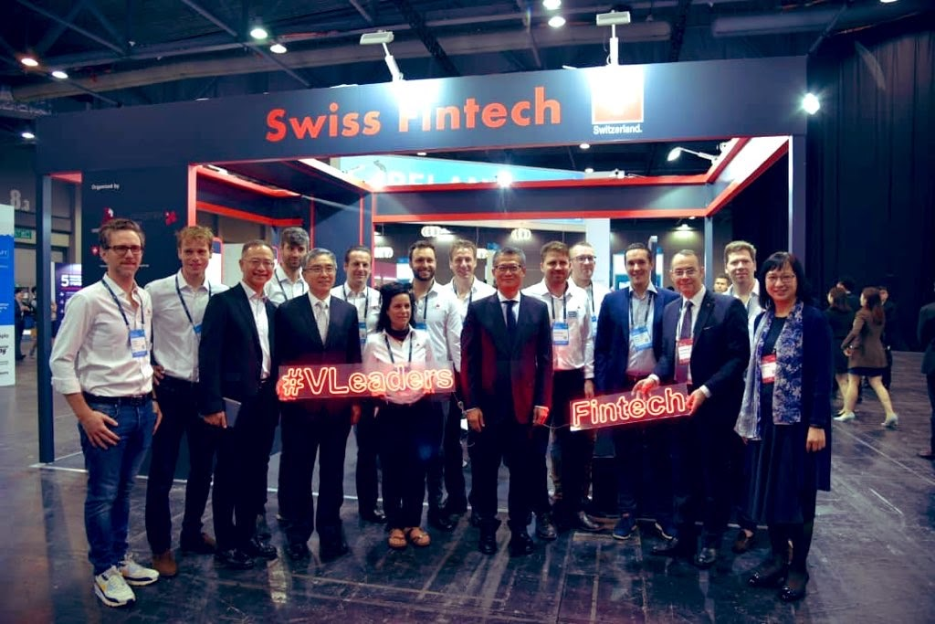

The Swiss Fintech Pavilion at the Hong Kong Fintech Week

On the last day, the startups had the chance to visit Fintech unicorns Tencent, WeBank, WeLab or ZhongAn Insurance in Shenzhen.

“It is a great experience to be here to represent my company, Billte, and to show the Hong Kong financial industry what we do.”, said Andrea Girasole, CEO of Billte, “This is extremely important for us as Asia is a booming market in general, and so are especially Hong Kong and China.”
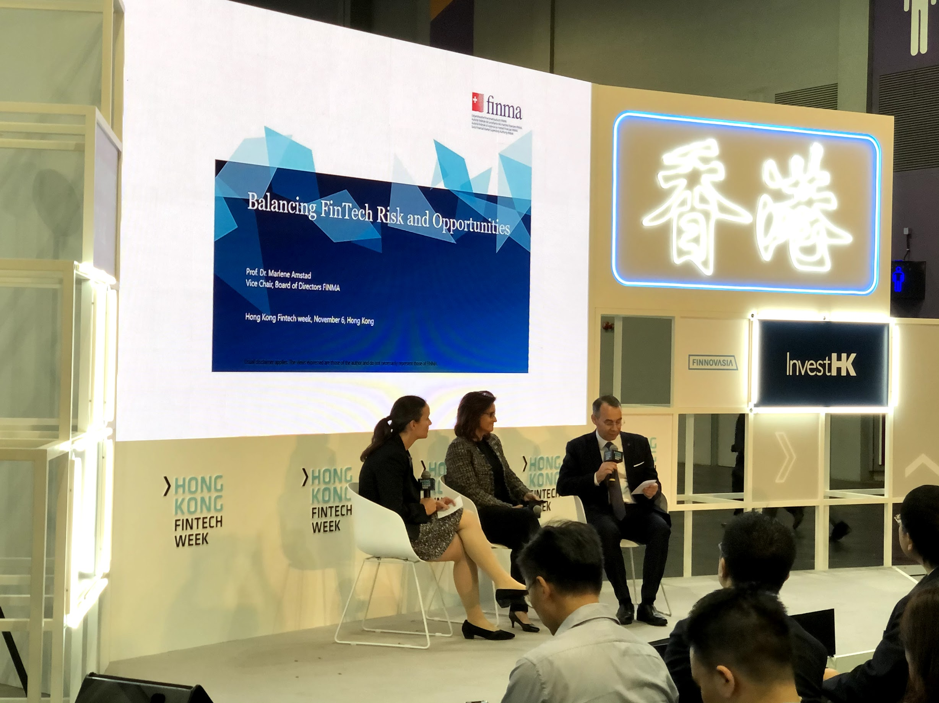
Panel discussion with Prof. Marlene Amstad, Vice Chair of the Board of Director, Swiss Financial Market Supervisory Authority FINMA, Suzanne Streit, Embassy of Switzerland in China and Dr. Felix Moesner, Science Consul & CEO of swissnex China

“The amazing 6-day Venture Leaders Fintech program was a great success, connecting our startups with investors, mentors, experts and highly-engaged audiences at the two flagship events” said Dr. Felix Moesner, Science Consul & CEO of swissnex China, “the outstanding quality of the Fintech startups clearly demonstrate Switzerland’s leading position as a global Fintech innovation hub.”

Venture Leaders Fintech 2019 is organized by Venturelab and swissnex China and supported by digitalswitzerland, EPF Lausanne, ETH Zurich, Finance 2.0, IMMOMIG, PostFinance, Presence Switzerland, Redalpine, Consulate General of Switzerland in Hong Kong, Walder Wyss, Canton of Zurich and Zühlke Engineering Hong Kong.

Venture Leaders Fintech 2019

Billte | Andrea Girasole | billte.ch | Zurich
Processing and tracking paper invoices is expensive and time consuming. Billte digitizes and automatizes companies' entire billing process. The Zurich-based startup already works with insurer Generali in Switzerland and is looking to expand into Indonesia this year.

Crypto Finance | Jan Brzezek | cryptofinance.ch | Zug
Implementing blockchain technology can be difficult for financial institutions and investors. Crypto Finance, Switzerland's first and only FINMA-regulated asset manager for crypto assets, offers exposure to reputable and regulated products in the crypto asset class via its own brokerage and fund.

Loanboox | Andi Burri | loanboox.com | Zurich
Debt capital markets are intransparent and public sector authorities seekings loans once-in-a-generation ill-positioned to understand them. Loanboox's independent debt capital platform simplifies the comparability of interest rates and legal clauses to allow municipalities and companies close deals with banks and institutional investors online.

Orca | Tomas Hurcik | orca.xyz | Zurich
Over the next seven years the largest transition of wealth ever is due to take place. The next generation of high- and ultra-high-net-worth individuals is digitally native and requires tools that balance their privacy with the need to share digital information with family, advisors and service providers. Orca's zero-knowledge platform is the single point of contact for coordinating this flow of information for individual and corporate clients.

Pexapark | Michael Waldner | pexapark.com | Schlieren
Renewable energy sales have become more complex and volatile as governments reduce subsidies. At the same time installed renewable capacity is set to double in the next five years. Pexapark's complete revenue management solution for renewables gives investors and renewable-energy-asset owners a single place to price energy sales, close transactions and monitor their energy risks.

Raized.AI | Penny Schiffer | raized.ai | Zurich
Venture capitalists need to manually review hundreds of pitchdecks before finding an investment, and startups pitch hundreds of VCs before winning funding. Raized.AI uses artificial intelligence to improve dealflow for VCs, to help the market clear more efficiently. The Zurich-based SaaS startups looks to expand its pilot customer base into three countries this year.

Tokenestate | Vincent Trouche | tokenestate.io | Geneva
Traditional processes to manage and verify investors in private companies and real-estate are obsolete, which makes it difficult to trade these assets in secondary markets. Tokenestate originates deals and offers digital securities - the digital representation of regulated financial instruments - on its own platform. The Neuchatel-based also helps startups and SMEs to manage their own token-sales, executing its first digital sale last year.

turicode | Martin Keller | turicode.com | Zurich
Eighty percent of business-relevant data is unstructured, much of it locked inside the 2.5 trillion PDFs created every year. In the financial industry document-heavy processes are considered part of the daily routine and often outsourced to humans in lower-wage countries. turicode uses machine-learning to train its information retrieval software MINT.extract to analyze documents more quickly and accurately.

vestr | Simon Hasenfratz | vestr.com | Zurich
Actively managed certificates are a growing class of structured products, whose dynamism makes them difficult for banks to manage and scale. Vestr's b-to-b platform simplifies this for financial institutions and their customers. The startup, with investors including the Swiss Stock exchange, aims to have more than a billion francs in assets on the platform by end of the year.

vlot | Daniel Schmidheiny | vlot.ch | Zurich
The complexity of modern social security systems is compounded by citizens having more dynamic employment and family lives. Understanding their own life insurance needs has become a big challenge. Vlot's software evaluates a family’s or individual's life insurance coverage needs and helps financial institutions advise them better.

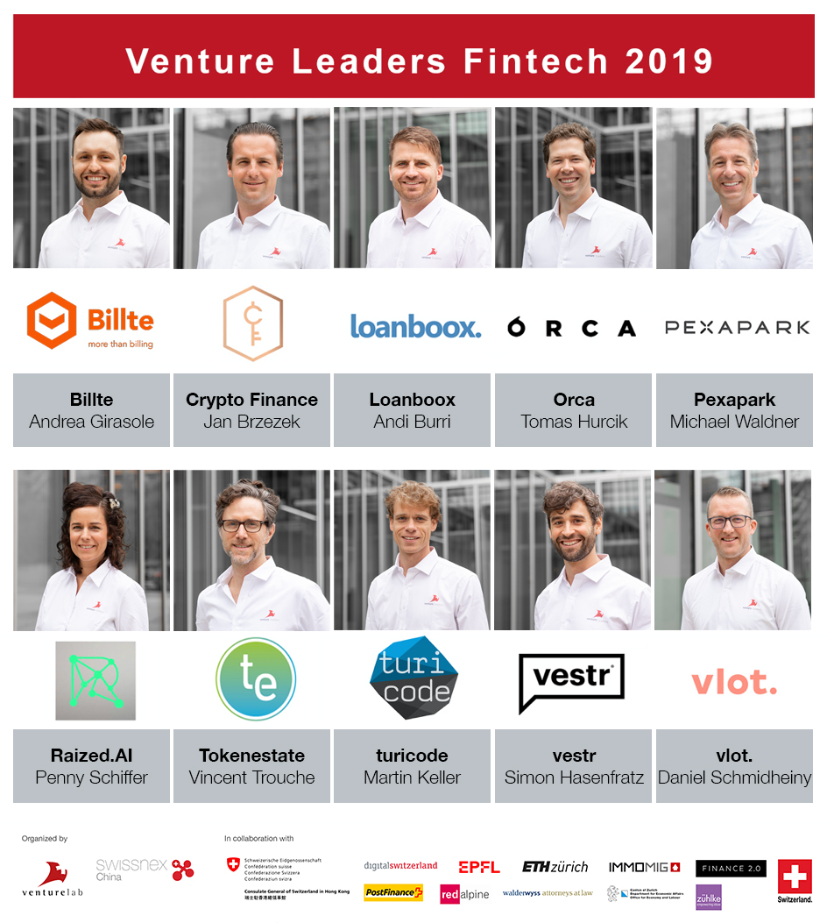

#####

About swissnex China

swissnex China is the Science Consulate of Switzerland in China, which builds bridges by connecting Switzerland and China in education, research and innovation. By crossing conventional boundaries, we offer a platform to foster collaboration and creativity for inspiring research and ground-breaking innovation. For more information, please visit:

swissnex China official website: https://www.swissnexchina.org/
swissnex China LinkedIn: https://www.linkedin.com/company/swissnex-china/
swissnex China Weibo: https://weibo.com/swissnexchina
swissnex China Twitter: https://twitter.com/swissnexChina

Further enquiries:

Mr. Danli ZHOU
Head of Marketing & Communications
swissnex China
danli.zhou@swissnexchina.org
Tel: + 86 21 6235 1889

